Sure! Here’s a detailed step-by-step guide to create a contact form in Python using Flask that saves data to a MySQL database with XAMPP.

Prerequisites

1. Install XAMPP:

- Download and install XAMPP from [Apache Friends](https://www.apachefriends.org/index.html).

- Start the XAMPP Control Panel and ensure the Apache and MySQL services are running.

2. Install Python:

- Download and install Python from [python.org](https://www.python.org/downloads/).

- Make sure to check the option to add Python to your PATH during installation.

3. Install Required Python Packages:

- Open your command line or terminal and install Flask and MySQL connector:



Step 1: Set Up the MySQL Database

1. Access phpMyAdmin:

- Open your web browser and navigate to `http://localhost/phpmyadmin`.

2. Create a New Database:

- Click on the "Databases" tab.

- In the "Create database" field, enter `contact_db` and click "Create".

3. Create a New Table:

- Select `contact_db` from the left sidebar.

- Click on the "SQL" tab and run the following SQL query to create a `contacts` table:

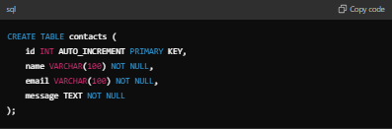

- This command creates a table with columns for `id`, `name`, `email`, and `message`.

Step 2: Create the Flask Application

1. Set Up Project Structure:

- Create a new folder for your project, e.g., `contact_form`.

- Inside this folder, create another folder named `templates`.

2. Create the Flask Application File:

- In the `contact_form` folder, create a file named `app.py` and open it in a text editor. Paste the following code:

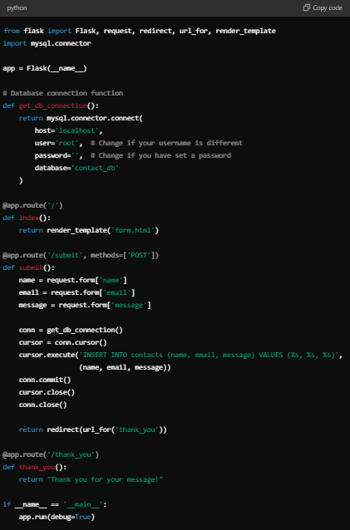

Explanation:

- `Flask`: The web framework for creating web applications.

- `mysql.connector`: Library to connect Python with MySQL.

- `get_db_connection()`: A function to connect to the MySQL database.

- Routes:

- `/`: Displays the contact form.

- `/submit`: Handles form submissions and inserts data into the database.

- `/thank_you`: Displays a thank you message after submission.

Step 3: Create the HTML Form

1. Create the HTML Form:

- In the `templates` folder, create a file named `form.html` and paste the following HTML code:

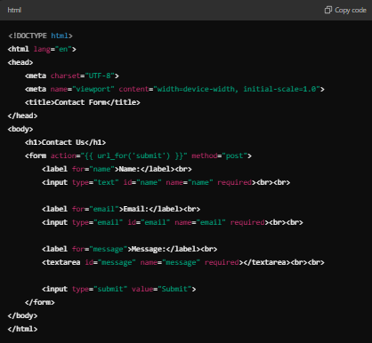

Explanation:

- This HTML file contains a form where users can input their name, email, and message. When the form is submitted, it sends a POST request to the `/submit` route.

Step 4: Run the Application

1. Open a Terminal:

- Navigate to the directory where `app.py` is located:



2. Run the Flask Application:



- You should see output indicating that the server is running, usually at `http://127.0.0.1:5000/`.

3. Access the Form:

- Open your web browser and go to `http://127.0.0.1:5000/`. You should see the contact form.

Step 5: Testing the Form

1. Fill Out the Form:

- Enter your name, email, and a message, then submit the form.

2. Check for Success:

- After submission, you should be redirected to a thank you page. The data should now be saved in the `contacts` table in your `contact_db` MySQL database.

3. Verify Data in MySQL:

- Go back to `http://localhost/phpmyadmin`, select `contact_db`, and view the `contacts` table. You should see your submitted data.

Conclusion

Congratulations! You have successfully created a contact form using Flask and connected it to a MySQL database via XAMPP. You can further enhance this application by adding features such as:

- Input validation.

- Error handling for database connections.

- Sending email notifications on form submission.

- A user-friendly front-end design.

Feel free to ask if you have any questions or need further assistance!